Practical No:-6
Create a Simple Restful Service to demonstrate CRUD operations with “Player”
database. Implement the service with fields viz. Player_Name, age, Country,
Runs. Deploy the service and execute the operations.
Step1: Create a datbase and table
mysql>create database playerdb_sufyan6111;
mysql>use playerdb_awaizkhan6013;
mysql> create table Player(playername varchar(50),playerage int, country varchar(50), runs int);
mysql> show tables;
mysql> desc Player;
mysql> select * from Player;

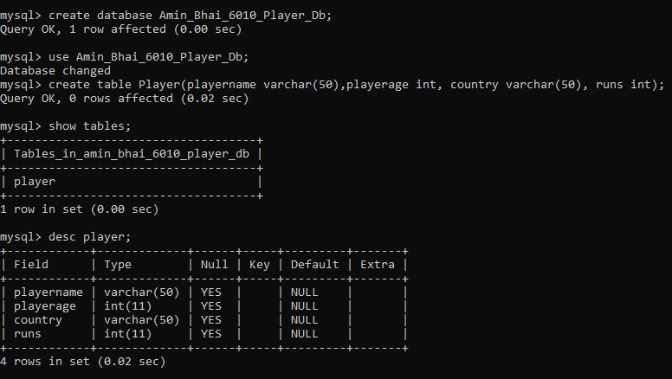
Insert Data
package ServerPackage;
import javax.ws.rs.core.Context;
import javax.ws.rs.core.UriInfo;
import javax.ws.rs.Produces;
import javax.ws.rs.Consumes;
import javax.ws.rs.GET;
import javax.ws.rs.Path;
import javax.ws.rs.PUT;
import javax.ws.rs.core.MediaType;
import java.sql.*;
@Path("generic")
public class GenericResource {
@Context
private UriInfo context;
public GenericResource() {
}
@GET
@Produces(MediaType.APPLICATION_XML)
public String getXml() {
//TODO return proper representation object
throw new UnsupportedOperationException();
}
@PUT
@Consumes(MediaType.APPLICATION_XML)
public void putXml(String content) {
}
@PUT
@Consumes(MediaType.APPLICATION_XML)
@Path("/ExecuterQuery")
public String executeMyquery(String query)
{
try
{
Class.forName("com.mysql.jdbc.Driver");
String url = "jdbc:mysql://localhost/playerdb_awaizkhan6013";
Connection con = DriverManager.getConnection(url,"root","maha");
Statement st = con.createStatement();
String q = query:
st.execute(q);
st.close();
con.close();
return "Query is Executed!!!";
}
catch (Exception e)
{
return e.getMessage();
}
}
}

Output:-
Insert Query
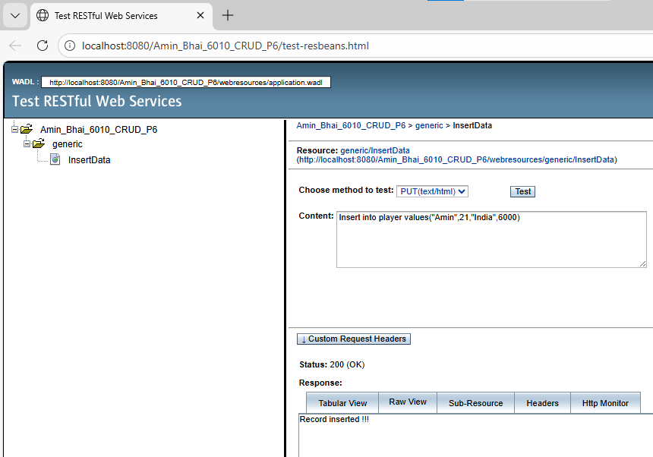
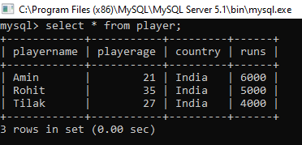

Update Query
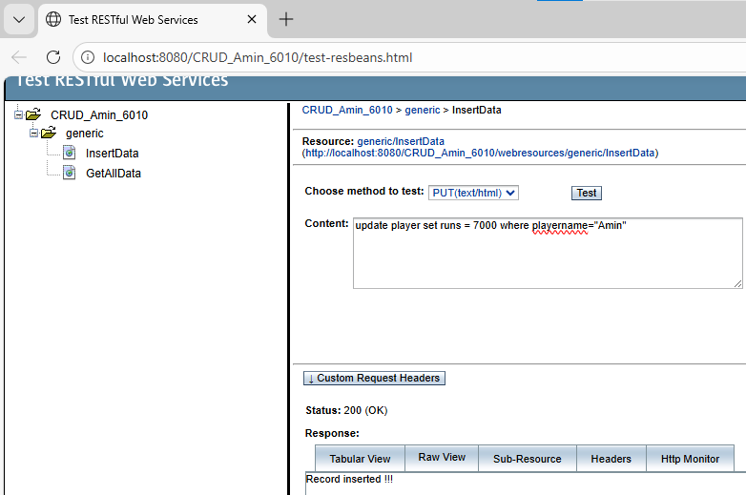

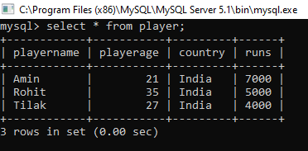

Delete Query
